Queenscliffe and District Neighbourhood House

Strategic PLAN 2018-2020
July 22nd 2017 | Facilitated by Kylie Pollock kpconsultations@bigpond.com

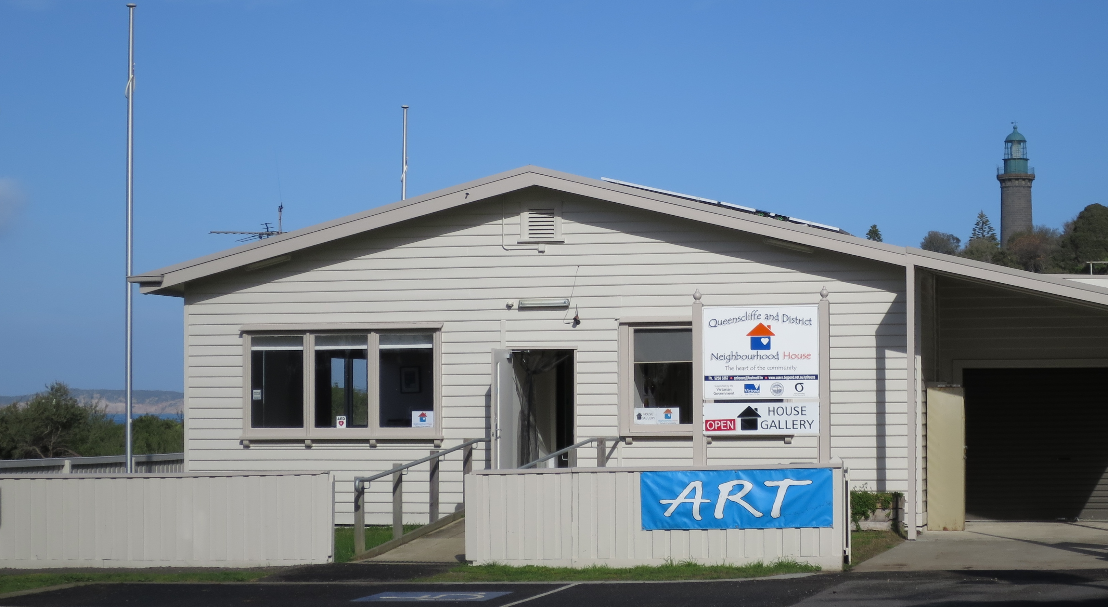

Vision
‘To be an innovative Neighbourhood House responsible to our communities’ needs’

Contents
What is a Neighbourhood House? Page 3
Why does QNH need a Strategic Plan? Page 4
What does a Strategic Plan need? Page 4
Circular continuous improvement process Page 4
QNH Mission, Values, Aims. Objectives Page 5
Evaluation of the 2014-2017 strategic plan Page 6
Establishing the context for development of the 2017-2020 Strategic Plan Page 7
The 2018-2020 Strategic Plan Pages 8-10

What is a Neighbourhood House?
Neighbourhood Houses bring people together to connect, learn and contribute in their local community through social, educational, recreational and support activities, using a unique community development approach. Community development is about enabling communities to identify and address their own needs. It starts from the assumption that communities have existing strengths and assets that make them part of the solution. Activities and programs develop in relation to the needs of the neighbourhood, other community local infrastructures and resource constraints.

Neighbourhood Houses were first established in Victoria in the early 1970s. The movement grew from the grass roots out of local community need, particularly the isolation of women in the community. During the 1970s, as the sector grew, the first Network of houses was established in 1978. A peak body now known as Neighbourhood Houses Victoria was formed in 1979.

Initially, most houses & centres were staffed by volunteers with only small amounts of federal, state & local government funding. In 1986, the the Neighbourhood House Coordination Program (NHCP), was established by the Victorian state government to provide secure, recurrent funding for the coordination of activities. Other sources of funding can include Adult Community and Further Education (ACFE), Local Governments and Philanthropic organisations.

Most Neighbourhood Houses are community owned generalist services. Some are auspiced by Local Governments, Health Services or charitable organisations, but all are unequalled in their ability to provide a continuity of service to people through their changing life stages. The sector has withstood the challenges of sustaining local communities in a climate of dramatic change over the past few decades. Today there are over around 400 Neighbourhood Houses and 15 Neighbourhood House Networks in Victoria and over one thousand throughout Australia. The number continues to increase in response to the ever-changing needs of diverse communities.
Source: https://www.nhvic.org.au/documents/item/38

Why does Queenscliff and District Neighbourhood House need a Strategic Plan?
- A strategic plan provides an agreed process to achieve the Vision and Mission of QNH
- It will document what success looks like and what is need to get there
- It will help to keep everyone on the same page
- It builds engagement, commitment and motivation
- It will document measurable goals that can be monitored, assessed and adjusted if needed
- Strategic Planning provides evidence to your community and funding bodies that you know what your are doing and where you are going

What is included in this Strategic Plan?

- Vision statement- this articulates how we see our organisation in the future: ‘To be an innovative Neighbourhood House responsive to our communities’ needs.’
- Mission statement-this articulates our reasons for existence: ‘To provide a range of services based on the assessment of community needs and demands’.
- Values/Aims/Objective- these guide all aspects of the way QNH is governed and managed.
- Pillars- these are the vital structures and systems that support the work of QNH.
- Goals- these define the specific outcomes QNH aims to achieve during the next 3 years.
- Tasks- these detail how each goal will be achieved.

Circular continuous improvement process

Delivery of the Strategic plan is monitored by the Committee of Management who prioritize Goals and Tasks each year in an Annual Plan that guides the work of the Coordinator to develop a program of courses, classes, events and activities based on the needs and aspirations of the community. The Coordinator recruits, trains and supports tutors, class leaders and volunteers who all contribute to delivery of the QNH program.

QNH Mission statement - this articulates our reasons for existence:
‘To provide a range of services based on the assessment of community needs and demands’

QNH Values, Aims and Objectives – these guide all aspects of the way QNH is Governed and Managed
Values

- Accessible
- Non- sexist
- Apolitical
- Non-judgmental
- Flexible
- Safe
- Welcoming
- Diverse
- Supportive
- Friendly
- Efficient
- Effective
- Non-threatening
- Accountable
- Environmentally responsible
- Respond to need of the community
- Enable individuals to reach their potential
- Involve the community
- Build a sense of community
- Provide equity of opportunity

Aims
- Foster a spirit of unity in the community
- Provide a centre for activities that will meet the need of a wide range of community groups
- Encourage the community to be active in organizing and implementing activities
- Create as neighbourhood network that is a focal point for exchange and interaction between groups and individuals at the local level
- Provide scope and support for personal enrichment and involvement for people of all ages and backgrounds
Objectives
- Provide appropriate avenues for a Neighbourhood House and its activities
- Determine the needs of the community for Neighbourhood House activities
- Provide a program of activities to advance the aims of ‘community involvement, support, interaction and education’
- Act as an information, resource and advisory service

- The Vision, Mission, Values, Aims and Objectives were developed when QNH was established in 1986

Evaluation of the 2014-2017 Strategic Plan

Present at this session were the Committee of Management and the Coordinator
The 2014 -2017 plan saw the development of three Strategic Themes:
1. Strengthening Relationships and Raising Profile
2. Ensuring an Accessible Facility
3. Governance Strength and Accountability
A range of activities were identified under each theme. During the life of this plan the Committee of Management, Coordinator and group/activity leaders regularly monitored progress. It is a credit to QNH that all identified activities in this strategic plan were achieved.

On review, a range of strengths, constraints and opportunities were identified for consideration in the 2017-2020 plan.

Strengths:

Stable Governance and Management
Stable venue
Stable funding and financial position
Great reputation
Dedicated volunteers and engaged participants
Varied, responsive and dynamic program of activities
The biggest strength of QNH is its people

Constraints:

Changing staff in other organisations affected relationship building
Funding limitations dictate the availability of paid staff
Some participants are unaware that their group is a program of QNH
Some local residents still don’t know that QNH exists or what it offers
Few, if any residents have taken advantage of the offer of transport.

Opportunities:
Ensure the Strategic plan lines up with, Vision, Mission, Values and policies of QNH
Ensure all the above documents are used to guide decision-making
Ensure all the above documents are communicated when recruiting and training new Committee members and volunteers
Investigate additional ways to report back to the community, for example posters, social media, local newsletters and press
Population growth in Point Lonsdale - opportunity to engage with new residents
Census data will assist in program and promotion planning that reflects the community
Ongoing collection of participant data would assist in program and promotion planning
Promotion directly to residents of local aged care facilities may result in more participation from these community members

Establishing the context for development of the 2018- 2020 strategic plan Present at this session were COM, coordinator, an office volunteer, men’s shed members and tutors.

The group identified the following adjectives that describe what QNH means to them:

Welcoming
Inclusive
Friendly
Educational
Open

Hideaway, Gentle, Organised, Positive,
Informative, Active, Fun, progressive
Diverse, Personal, Successful, Happy,
Arty, Green/Enviro, Comfortable.

A statement that encompasses the most identified words could be:
‘QNH is a Welcoming, Inclusive and Educational place where people are Friendly and processes are Open.’

The years of experience and knowledge of all present in this session totaled 153 years!

Pillars - vital, integral, systems and structures that allow QNH to function
The group brainstormed and identified the essential Pillars that support QNH in its work.
- Governance- legal entity, including sub-groups, finance, risk management, compliance, policy development, planning, monitoring, employer, Incorporations Act compliance, signatory to funding agreements.
- Operational Management- accountable to COM, advise & inform the COM, implement strategic and policy framework, manage resources, operations and delivery, needs analysis, program planning, delivery & evaluation, administration, grant writing and reporting, volunteer and tutor management.
- Relationships- Internal: COM, staff, tutor & volunteers, auspiced groups, house participants. External: wider Neighbourhood House sector, funding bodies, local clubs, organisations, churches, educational organisations, services and businesses, local and State Govt. officers and representatives, local press and radio, residents of QNH and district.
- Infrastructure= the physical building, maintenance, renovation projects, eco initiatives, accessibility, leasing arrangements, future planning.
- Culture= Vision, Mission, Values, Aims, Objectives, Policies, employment & conditions and recognition, QNH reputation.

The 2018-2020 Strategic Plan

Pillar 1. Governance
Goals - A desired result or outcome that QNH commits to achieving during the life of this strategic plan. | Status
1.1 Welcome Pack
Review and update the welcome pack for new committee members and ensure that it contains
information which clearly defines roles and responsibilities.

1.2 COM skills analysis
Conduct a skills analysis of COM members and recruit or co-opt additional members to fill
identified gaps.

1.3 QNH Policies
Review and where necessary, update QNH Policies. Link Policies with the relevant sub-
committees.

1.4 Co-ordinator and COM Succession Plan
Document and implement a succession plan for Co-ordinator and COM members to ensure
continuity and a highly functioning organisation.

1.5 Financial Management
Ensure financial viability of QNH by maintaining a year’s funds in reserve.

Pillar 2. Management | Status
2.1 Community Needs Analysis
- Conduct a whole of community needs analysis.
- Align existing program to meet identified needs.
- Include strategies to attract and support more interest groups.

2.2 Promotional plan
- Develop, implement and evaluate an ongoing promotional plan.
- Include strategies to engage with new and existing users.
- Develop and implement a comprehensive promotional strategy based on an analysis of population data, and the community needs analysis (2.1).
- Include targeted and specific strategies to engage with the growing community at ‘The Point’
and the Golf Course.
e) Support QNH groups to engage externally with local groups, schools and events,
particularly the Men’s Shed.
f) Develop and implement tools to measure success of the plan.

2.3 Volunteers
- Conduct an analysis of current deployment and unmet need for volunteers at QNH.
- Document ongoing support available to volunteers at QNH.
- Document volunteer recruitment strategy.
- Recruit volunteers for areas of unmet need at QNH.

2.4 Grant writing
- Develop a priority wish list to guide Grant writing over the life of this plan.
- Seek Grants that align with identified needs within QNH.
- Seek Grants that align with organisational needs at QNH.

Pillar 3. Relationships | Status
3.1 Stakeholder Analysis
- Conduct a stakeholder analysis to identify the priorities of stakeholders.
- Pursue partnerships with stakeholders whose priorities align with those of QNH.
- Be receptive to offering programs externally and where appropriate, do so.

Pillar 4. Infrastructure | Status
4.1 QNH Tenancy
Secure tenancy of QNH in its current location.

4.2 Use of space at QNH
Conduct a comprehensive analysis of the current use and configuration of space at QNH and
implement recommendations for improvements.

4.3 Infrastructure wish list
Develop and prioritise a short, medium and long term wish list of future infrastructure
requirements and negotiate program of works with Borough.

Pillar 5. Culture | Status
5.1 Review current Vision, Mission, Values, Aims and Objectives
  - Ensure they are succinct and reflective of QNH.
  - Include the reviewed Vision Statement in all QNH documents to promote the unique culture,
philosophy and practice of QNH.

5.3 Employment and volunteer documents
Review all employment and volunteer documents to ensure they accurately reflect the culture,
philosophy and practice of QNH.

